КЫРГЫЗСКИЙ ТЕХНИЧЕСКИЙ УНИВЕРСИТЕТ им. И. Раззакова

ФАКУЛЬТЕТ ИНФОРМАЦИОННЫХ ТЕХНОЛОГИЙ

Кафедра «ПРОГРАММНОЕ ОБЕСПЕЧЕНИЕ КОМПЬЮТЕРНЫХ

СИСТЕМ»

Дисциплина

Методы оптимизации

Отчет

по практической работе №2

«Разработка ПО для поиска **максимальной и минимальной точки *экстремума*** на основе метода: ***Even Search Method***»

Выполнил: студент группы ПИ-2-16

Калыков Алишер

Проверил: кандидат технических наук, профессор

Тен Иосиф Григорьевич

Оглавление

Раздел №1 Наименование работы 3

Раздел №2 Спецификация проблемы 3

Раздел №3 Стадии проектирования системы 3

Раздел №4 Документирования этапов проектирования интерфейсной формы системы 5

Раздел №5 Стадии конструирования ПО 7

Раздел №6 Тестирование 13

# Раздел №1 Наименование работы

Разработка ПО для поиска **максимальной и минимальной точки *экстремума*** на основе метода: ***Even Search Method.***

# Раздел №2 Спецификация проблемы

Mathematical description of the algorithm:

Case (i): IF f(x(k))>=f(x(k-1)) THEN x(k+1)=x(k); ELSE x(k+1)=x(k)+H; For all k=0,1,2,…;

Where k – is a number of iteration; x(k) – is an approximate value of the searching variable x on the k-th iteration.

Note: It is the algorithm of the Even Search Method to find a minimum of a given objective function.

Figure 1a: Flow-chart of the Even Search Method (find minimum) is shown below.

Case (ii): IF f(x(k))<=f(x(k-1)) THEN x(k+1)=x(k); ELSE x(k+1)=x(k)+H; For all k=0,1,2,…;

Where k – is a number of iteration; x(k) – is an approximate value of the searching variable x on the k-th iteration.

Note: It is the algorithm of the Even Search Method to find a maximum of a given objective function.

Figure 1b: Flow-chart of the Even Search Method (find maximum) is shown below.

# 

# Раздел №3 Стадии проектирования системы

1. Разработка блок-схемы Even Search Method:



1. Разработка пользовательского интерфейса.

Форма для взаимодействия пользователя с программой представлена ниже:

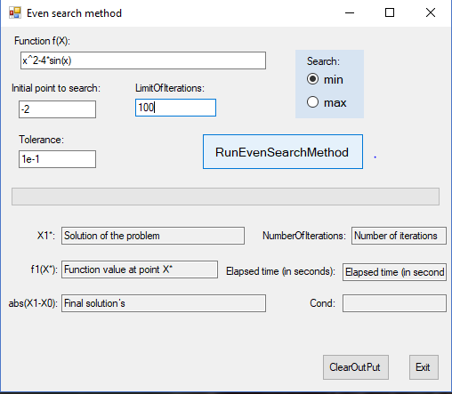

# 

# Раздел №4 Документирования этапов проектирования интерфейсной формы системы

1. Документирование процесса задания свойств элементов интерфейсной формы системы



1. Таблица 1: Настройки элементов управления интерфейсной формы системы

|  |  |  |  |
| --- | --- | --- | --- |
| **Number of control** | **Control** | **Property** | **Setting** |
| 1 | Label1 | Appearance (Text) | Function f(x): |
| Design (Name) | Label1 |
| 2 | Textbox1 | Appearance (Text) | x^2-4*sin(x) |
| Design (Name) | funcBox |
| 3 | Label2 | Appearance (Text) | Initial point to search: |
| Design (Name) | LabelInitialPoint |
| 4 | Textbox2 | Appearance (Text) | -2 |
| Design (Name) | InitialPointBox |
| 9 | Label4 | Appearance (Text) | LimitOfIterations: |
| Design (Name) | LabelLimitOfIterations |
| 10 | Textbox4 | Appearance (Text) | 100 |
| Design (Name) | k_maxBox |
| 11 | Label5 | Appearance (Text) | Tolerance |
| Design (Name) | LabelTolerance |
| 12 | Textbox5 | Appearance (Text) | 1e-15 |
| Design (Name) | ToleranceBox |
| 13 | Button1 | Appearance (Text) | RunBisectionMethod |
| Design (Name) | ButtonRunPocketSearchMethod |
| 14 | ProgressBar1 | Behavior (Visible) | False |
| Design (Name) | ProgressBar1 |
| 15 | Label6 | Appearance (Text) | X1*: |
| Design (Name) | LabelRootOfEquation |
| 16 | Textbox6 | Design (Name) | SolutionOfTaskBox |
| Appearance (Text) | Solution of the problem |
| **Behavior (ReadOnly)** | True |
| 17 | Label7 | Appearance (Text) | F1(X*): |
| Design (Name) | LabelFunctionValue |
| 18 | Textbox7 | **Behavior (ReadOnly)** | True |
| Appearance (Text) | Function value at point X* |
| Design (Name) | ValueOfFunctionBox |
| 19 | Label8 | Appearance (Text) | NumberOfIterations: |
| Design (Name) | NumberOfIterations |
| 20 | Textbox8 | **Behavior (ReadOnly)** | True |
| Appearance (Text) | Number of iterations |
| Design (Name) | NumberOfIterationsBox |
| 21 | Label9 | Appearance (Text) | H0 |
| Design (Name) | LabelAbsError |
| 22 | Textbox9 | **Behavior (ReadOnly)** | True |
| Appearance (Text) | Final solutions |
| Design (Name) | AbsBox |
| 23 | Button2 | Appearance (Text) | ClearOutPut: |
| Design (Name) | ButtonClearOutPut |
| 24 | Textbox10 | **Behavior (ReadOnly)** | True |
| Design (Name) | elapsedTime |
| Appearance (Text) | Elipsed time (inseconds) |
| 25 | Label10 | Appearance (Text) | Elapsed time (in seconds): |
| Design (Name) | Label3 |
|  | Textbox | **Behavior (ReadOnly)** | True |
| Design (Name) | CondBox |
| Appearance (Text) | Condition |
|  | Label | Appearance (Text) | Cond |
| Design (Name) | Label5 |
| 26 | Label11 | Appearance (Text) | empty |
| Design (Name) | Label4 |
| 27 | Button3 | Appearance (Text) | Exit |
| Design (Name) | Button3 |
| 28 | RadioButton | Appearance (Checked) | True |
| Appearance (Text) | min |
| Design (Name) | minRadioButton |
| 29 | RadioButton | Appearance (Checked) | False |
| Appearance (Text) | max |
| Design (Name) | maxRadioButton |

# Раздел №5 Стадии конструирования ПО

1. Код программы на Visual Basic.NET, ***ассоцированный с интерфейсной формой*** “PocketForm.vb”, который ***реализует функции ввода и вывода данных*** и составляет Public Class “EvenForm”.

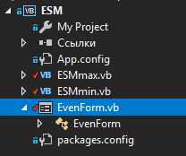



*********************Outset of the “Public Class EvenForm”

Option Explicit On

Imports System.Math

Imports info.lundin.math

Imports System.Threading

Public Class EvenForm

Sub Clean()

SolutionOfTaskBox.Text = "Solution Of Task"

ValueOfFunctionBox.Text = "Value Of Function"

NumberOfIterationsBox.Text = "Number Of Iterations"

elapsedTime.Text = "Elapsed time (in seconds)"

AbsBox.Text = "Final solution’s"

Label4.Text = ""

CondBox.Text = ""

End Sub

Private Sub Form4_Load(sender As Object, e As EventArgs) Handles MyBase.Load

Label2.Text = ""

SolutionOfTaskBox.Text = "Solution of the problem"

ValueOfFunctionBox.Text = "Function value at point X*"

NumberOfIterationsBox.Text = "Number of iterations"

elapsedTime.Text = "Elapsed time (in seconds)"

AbsBox.Text = "Final solution’s"

Label4.Text = ""

CondBox.Text = ""

End Sub

Private Sub ButtonExit_Click_1(sender As Object, e As EventArgs) Handles ButtonExit.Click

Close()

End Sub

Private Sub ButtonClearOutPut_Click(sender As Object, e As EventArgs) Handles ButtonClearOutPut.Click

Clean()

End Sub

Private Sub ButtonRunEvenSearchMethod_Click(sender As Object, e As EventArgs) Handles ButtonRunEvenSearchMethod.Click

Dim started As DateTime = Now

Dim finished As DateTime

ProgressBar1.Value = 0

Try

If (funcBox.Text = "" Or InitialPointBox.Text = "" Or

ToleranceBox.Text = "" Or k_maxBox.Text = "") Then

MsgBox("Input textboxes are empty! Enter the data")

Else

Clean()

If minRadioButton.Checked = True Then

Dim PM As ESMmin = New ESMmin()

Label2.Text = "Analytical expression of the function is: f(x) = " & funcBox.Text

PM.start(funcBox, InitialPointBox, ToleranceBox,

k_maxBox, ProgressBar1, Label4)

finished = Now

elapsedTime.Text = finished.Subtract(started).Seconds

PM.out(SolutionOfTaskBox, ValueOfFunctionBox, NumberOfIterationsBox, AbsBox, CondBox)

Else

Dim PM As ESMmax = New ESMmax()

Label2.Text = "Analytical expression of the function is: f(x) = " & funcBox.Text

PM.start(funcBox, InitialPointBox, ToleranceBox,

k_maxBox, ProgressBar1, Label4)

finished = Now

elapsedTime.Text = finished.Subtract(started).Seconds

PM.out(SolutionOfTaskBox, ValueOfFunctionBox, NumberOfIterationsBox, AbsBox, CondBox)

End If

End If

Catch ex As ParserException

MsgBox("A mistake is in the analytical expression of the function f(x)")

Catch ef As FormatException

MsgBox("A mistake is in the format of the input data")

End Try

End Sub

End Class

***********************Ending of the “Public Class EvenForm”

1. Код класса “ESMmin.cs” для нахождения минимума

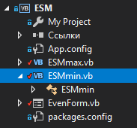

*********************Outset of the “Public Class ESMmin”

Option Explicit On

Imports System.Math

Imports info.lundin.math

Imports System.Threading

Public Class ESMmin

Dim func As String

Dim k As Integer

Dim SolutionOfTask As Decimal

Dim ValueOfFunction As Decimal

Dim FinalInaccuracy As Decimal

Dim FinalAbs As Decimal

Dim cond As Boolean

Public Sub out(SolutionOfTaskBox As TextBox, ValueOfFunctionBox As TextBox,

NumberOfIterationsBox As TextBox, AbsBox As TextBox, condBox As TextBox)

SolutionOfTaskBox.Text = SolutionOfTask

ValueOfFunctionBox.Text = ValueOfFunction

NumberOfIterationsBox.Text = k

AbsBox.Text = FinalAbs.ToString("0E0")

condBox.Text = cond

End Sub

Function F(par As Double) As Double

Dim Parser As New ExpressionParser()

Parser.Values.Add("x", par)

Return Parser.Parse(func)

End Function

Public Sub start(funcBox As TextBox, InitialPointBox As TextBox,

ToleranceBox As TextBox, k_maxBox As TextBox,

ByRef ProgressBar1 As ProgressBar, ByRef Label4 As Label)

Dim Tolerance As Double

Dim x0, x1 As Decimal

Dim H As Decimal

Dim YF0, YF1 As Decimal

Dim k_max As Integer

Dim CondK_Max As Boolean

cond = 0

CondK_Max = 0

func = funcBox.Text

x0 = Decimal.Parse(InitialPointBox.Text)

Tolerance = Double.Parse(ToleranceBox.Text)

k_max = Integer.Parse(k_maxBox.Text)

H = Tolerance

YF0 = CDec(F(CDbl(x0)))

x1 = x0 + H

YF1 = CDec(F(CDbl(x1)))

k = 0

Do

k = k + 1

If k = k_max Then

Dim rv As Long

rv = MsgBox("Attention: It isn't possible to find a solution with the given Tolerance = " _

& Tolerance & " and for a given Number Of Iterations =" & k_max & vbCrLf _

& "Continue searching?", vbYesNo Or vbQuestion)

If rv = vbYes Then

k_max = k_max + k_max

k_maxBox.Text = k_max

Else

CondK_Max = 1

Label4.Text = "Attention: It isn't possible to find a solution with the given Tolerance = " _

& Tolerance & vbCrLf & "and for a given Number Of Iterations =" & k_max

End If

End If

If YF1 >= YF0 Then

If k = 1 Then

cond = 1

Label4.Text = "Attention: It means that ESM can't find an extremum or Initial" _

& vbCrLf & "point Is x0 may be a solution Or may be the Initial point Is placed in the" _

& vbCrLf & "right-of-solution x* Is a forbidden arca." _

& vbCrLf & "Try to revise Initial point to check validity of the value 0."

End If

x1 = x0

YF1 = YF0

Else

x0 = x1

YF0 = YF1

x1 = x0 + H

YF1 = CDec(F(CDbl(x1)))

End If

ProgressBar1.Maximum = k + 0.00000001

ProgressBar1.Value = k

Thread.Sleep(0)

Loop While CondK_Max = 0 And cond = 0 And Math.Abs(x1 - x0) >= Tolerance

If Math.Abs(x1 - x0) < Tolerance Then

Label4.Text = "Answer: The minimum point of extremum find with the given Tolerance = " & Tolerance

End If

ProgressBar1.Visible = False

SolutionOfTask = x1

ValueOfFunction = YF1

FinalAbs = Math.Abs(x1 - x0)

End Sub

End Class

*********************Ending of the “Public Class ESMmin”

# Раздел №6 Тестирование

1. Тест №1 функция: x^2-4*sin(x)

Минимальная точка экстремума с погрешностью 1Е-1 и с максимальным количеством итерации: 100

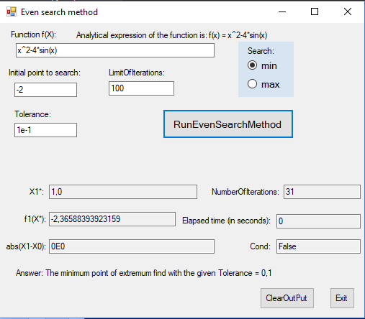

Сообщение о не нахождении результата за указанное количество итерации.

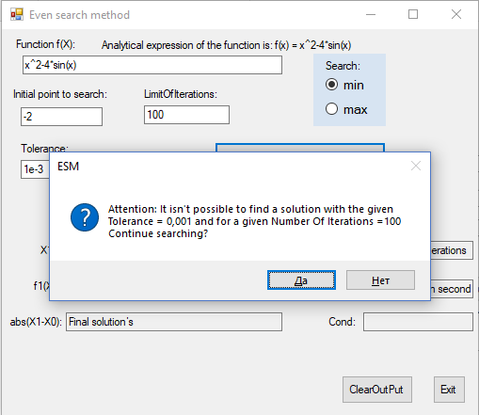

Невозможно найти решение за указанное количество итерации.

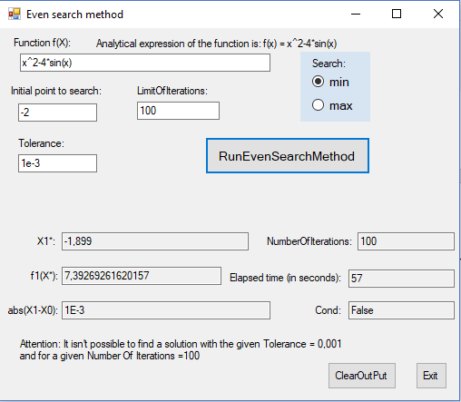

Решение может быть находится правее текущей начальной точки.

